Final Exam
Summer II 2017
The due date for the Final Exam is 8/8/2017 11:59 pm. It must be submitted through the “Final Exam”
in Dropbox provided on the eCollege. It is opened-book, opened-note, opened-Internet, but not
opened-friends or neighbor. It means that you have to do this exam by your own. You can use Internet
to check your syntax, but cannot ask anyone to do the exam for you. Partial credit might be given even if your answers are incorrect. For each question, please write comments to indicate the question that you want to answer (-10 points if you don’t).
The attachment name should follow the following convention: BUSA326_FINALEXAM_FIRSTNAME_LASTNAME . SQL

Part I: Creating Relational Database and Tables (52 points total)
Q1: Create database schema with name ‘Final Exam BUSA 326’ (2 points).
Q2: Create all tables based on the logical schema below. You need to correctly define primary keys,
foreign keys, constrains, and data type to get credits. Hint: final relational table designs were given in
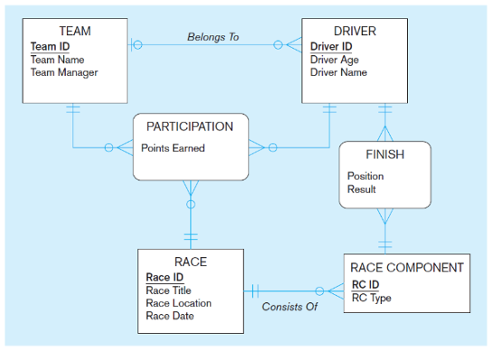midterm solutions (50 points).

Part II: Business Analytics Questions (48 points total: 6 points each question)
Import the final exam data code and use the following logical schema to answer all questions below.

1. Count all students who major in English.
2. Show major, first name and last name of students who take class on Monday.
3. Show first name, last name, major, and full address of students (return total 4 columns).
4. Show staff’s first name, staff’s last name, and salary of staff who get hired after Dec 1992
(return total 3 columns).
5. Display subject, department name which offers that subject, category of that subject, and
professor’s first name and last name who taught that subject (return total 5 columns).
6. Show all info of students who took more Monday class(es) than Tuesday class(es).
7. Do we have more students who are single than who are married? Must return ‘Yes’ or ‘No’.
8. Find classroom(s) that do not fill out half of its capacity per classes.

• Answers are detailed, accurate, and codes are correct.

***************************NOTE *************************************

Please feel free to consult your instructor by email or phone, if you have questions or need assistance!!
